**דוח מעבדה 9**

**שמות מגישים:**

סער ויקטור – 312392822

אילון בן סימון – 312162951

**תרגיל 1**

קוד התכנית:  
header :

#ifndef example1

#define example1

#include<stdio.h>

#include<conio.h>

#include<stdlib.h>

#include<math.h>

//functions declaration

double sum_square(int m, int n, float(*f)(int a));

#endif

Main:

#include"example1.h"

float func1(int x)

{

return (1.0 / x);

}

float func2(int x)

{

return (x / 5.0);

}

int main()

{

printf("The sum of func2: %.5lf\n", sum_square(2, 13,func2));

printf("The sum of func1: %.5lf\n ", sum_square(1, 10000,func1));

getch();

return 0;

}

Implementation:

#include"example1.h"

double sum_square(int m, int n, float(*f)(int a))

{

double sum = 0;

while (n >= m)//calculate the sum squre from n to m

{

sum += pow(f(n), 2);

n--;

}

return sum;

}

פלט 1:

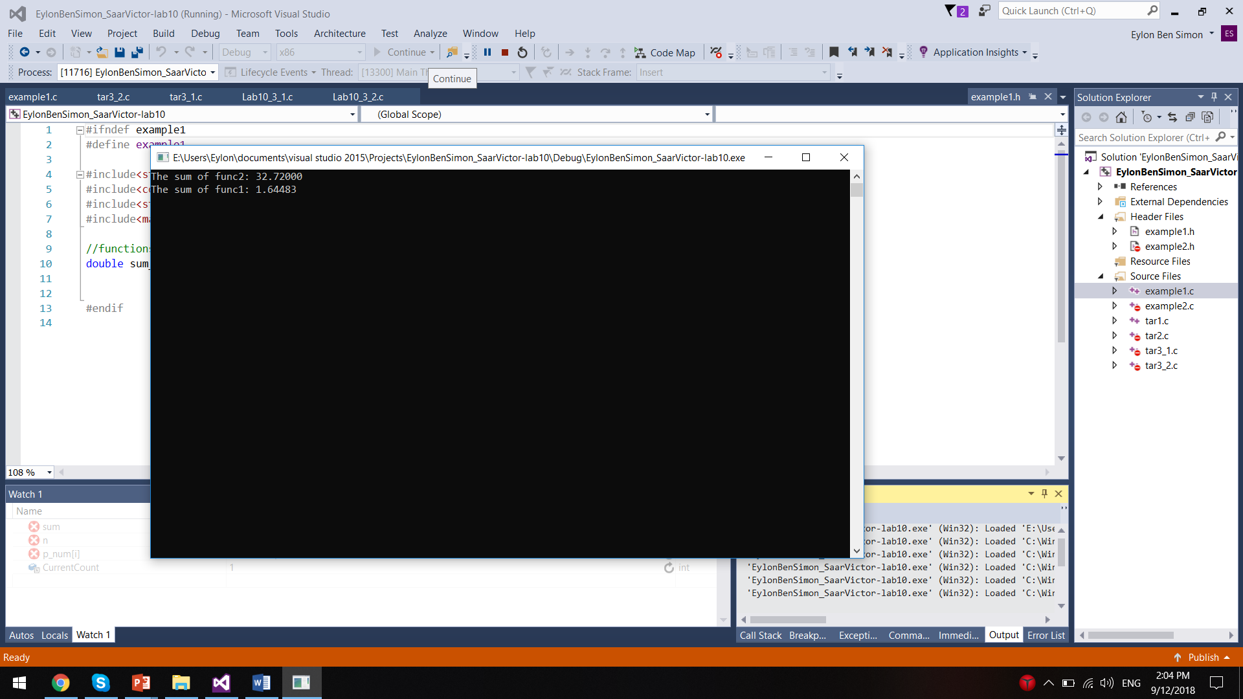

**תרגיל 2**

קוד התכנית:

header :

#ifndef example2

#define example2

#include<stdio.h>

#include<conio.h>

#include<stdlib.h>

#include<math.h>

#define N 5

//functions declaration

typedef enum { FALSE, TRUE } BOOL;

BOOL Sum(BOOL(*f)(void *, void *, void *), void **p_num, void *number);

#endif

Main:

#include"example2.h"

BOOL Int_Sum(void *a, void *b, void *c)

{

if (*(int*)a + *(int*)b == *(int*)c)

return TRUE;

return FALSE;

}

BOOL Float_Sum(void *a, void *b, void *c)

{

if (*(float*)a + *(float*)b == *(float*)c)

return TRUE;

return FALSE;

}

int main()

{

int num[] = { 3,5,23,5,6 }, i, value;

float fnum[] = { 3.5,5.0,2.3,5.8,6.2 }, fvalue;

void *p_num[N];

for (i = 0; i < N; i++)//fillings the pointers array

{

p_num[i] = &num[i];

}

printf("\nPlease enter an integer number ");

scanf("%d", &value);

if (Sum(Int_Sum, p_num, &value) == TRUE)

printf("There is such sum\n");

else

printf("There is no such sum\n");

for (i = 0; i < N; i++)//fillings the pointers array

{

p_num[i] = &fnum[i];

}

printf("\nPlease enter a float number ");

scanf("%f", &fvalue);

if (Sum(Float_Sum, p_num, &fvalue) == TRUE)

printf("There is such sum\n");

else

printf("There is no such sum\n");

getch();

return 0;

}

Implementation:

#include"example2.h"

//The function cheacks if the sum of two numbers is equal to third number

BOOL Sum(BOOL(*f)(void *, void *, void *), void **p_num, void *number)

{

int i, j;

for (i = 0; i < N; i++)

{

for (j = i+1; j <= N-1; j++)

{

if (f((p_num)[i], p_num[j], number) == TRUE)

return TRUE;

}

}

return FALSE;

}

פלט 1:

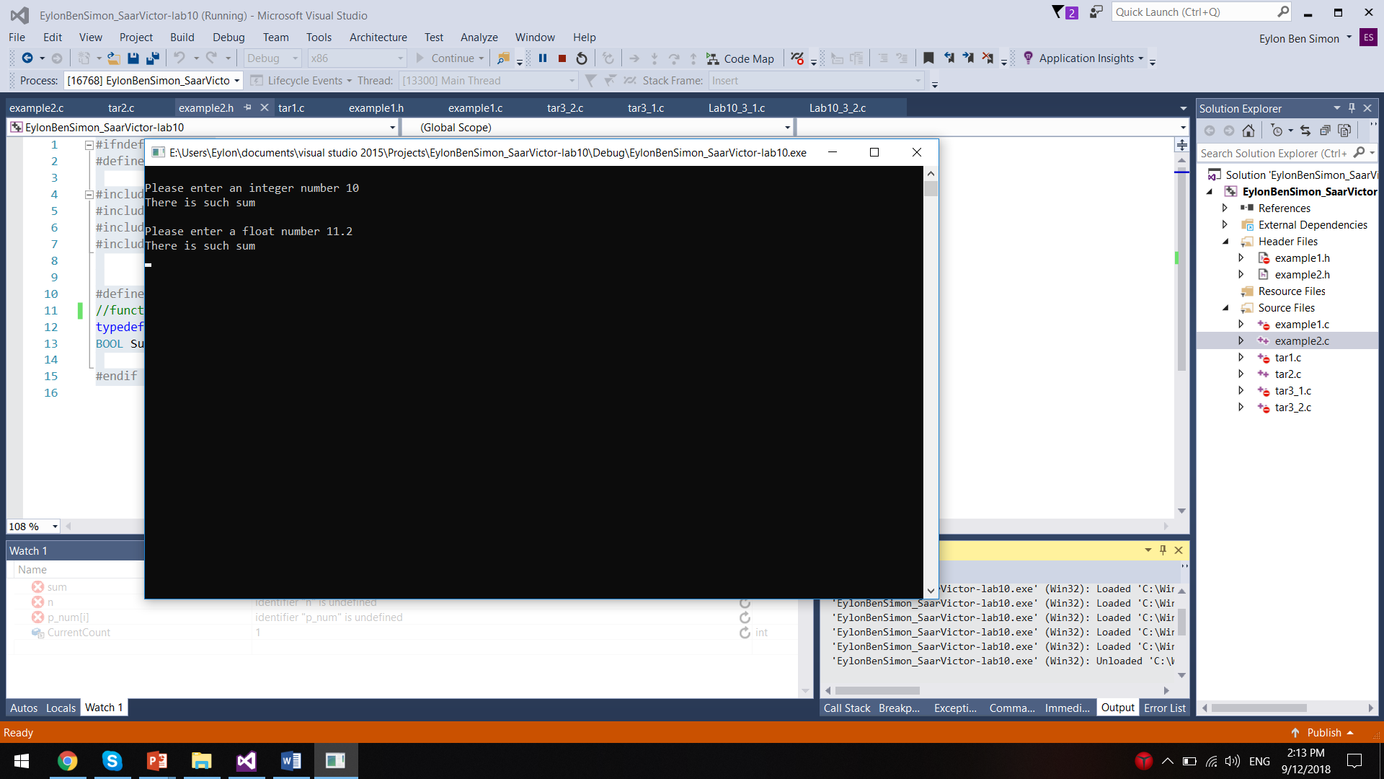

פלט 2:

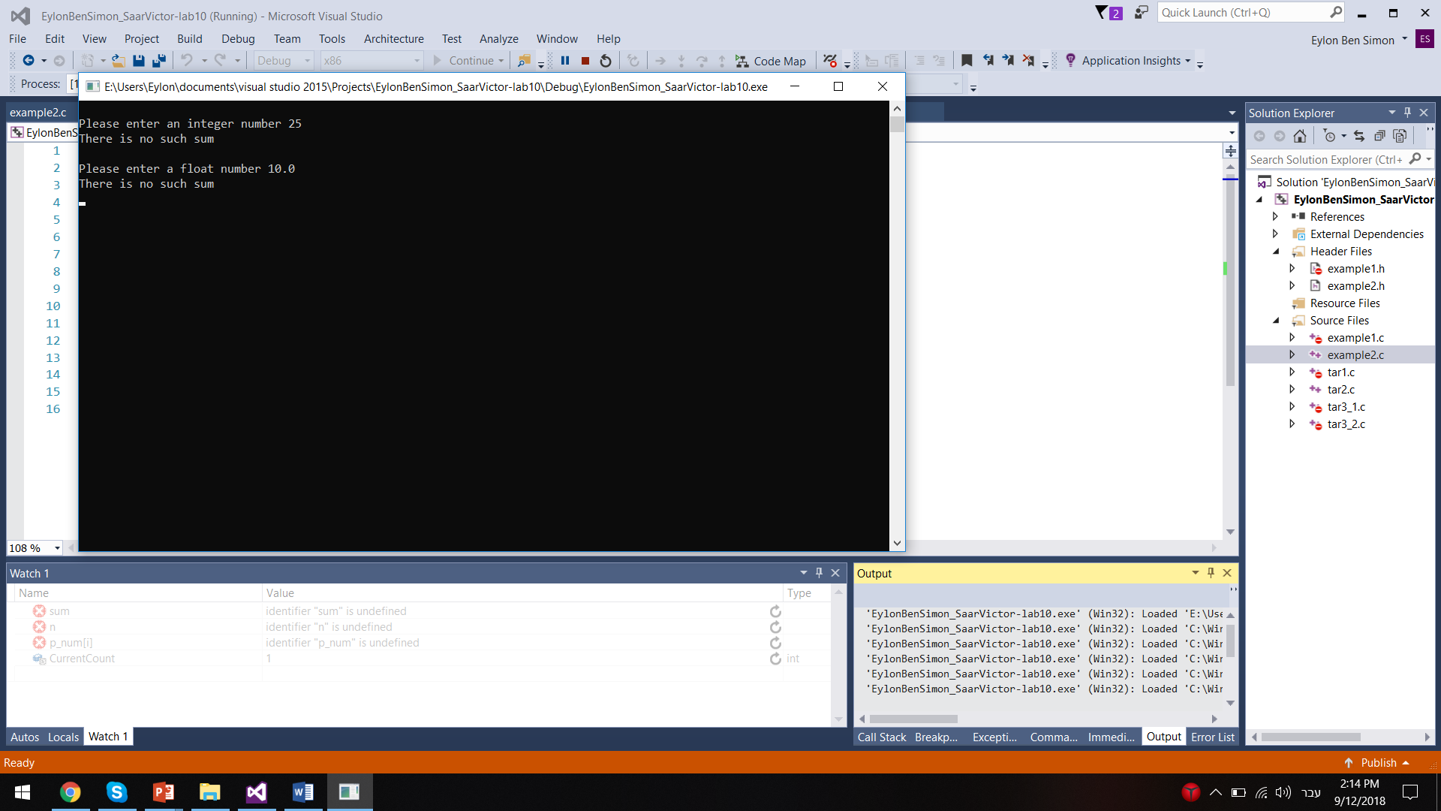

**תרגיל 3**

קוד התכנית עבור int:

#include<stdio.h>

#include<string.h>

#include<stdlib.h>

#include<conio.h>

#define N 5

typedef enum { FALSE, TRUE } BOOL;

void Insert(BOOL(*f)(void *, void *), void *Element, void ** Parray);

BOOL Int_Comp(void *FirstElement, void *SecondElement);

BOOL IsFull();

int CurrentCount = 0; /*global variable - only for the first ADT lab!Please,don't use!*/

int main()

{

int Array[N], Value, i;

void* PArray[N]; /*pointers array*/

printf("Enter numbers, -999 to stop");

scanf("%d", &Value);

while (Value != -999)

{

if (!IsFull())

{

Array[CurrentCount] = Value;

Insert(Int_Comp, &Array[CurrentCount], PArray); /*call the general function*/

scanf("%d", &Value);

}

else

{

printf("The array is full");

break;

}

}

printf("\n Your sorted array is:\n"); /*print the array in sorted order*/

for (i = 0; i < CurrentCount; i++)

printf(" %d ", *(int*)PArray[i]);

getch();

return 0;

}

BOOL IsFull()

{

if (CurrentCount == N)

return TRUE;

return FALSE;

}

BOOL Int_Comp(void *FirstElement, void *SecondElement)

{

if (*(int*)FirstElement > *(int*)SecondElement)

return TRUE;

return FALSE;

}

//The function insert the new element in the right place

void Insert(BOOL(*f)(void *, void *), void *Element, void ** Parray)

{

int i = CurrentCount - 1;

while(i>=0 && f(Element, Parray[i])==FALSE)//while elemnt<parray[i]

{

Parray[i + 1] = Parray[i];

i--;

}

Parray[i + 1] = Element;

CurrentCount++;

}

קוד התכנית עבור char:

#include<stdio.h>

#include<string.h>

#include<stdlib.h>

#include<conio.h>

#define N 5

#define LENGTH 30

typedef enum { FALSE, TRUE } BOOL;

int CurrentCount = 0; /*global variable - only for the first ADT lab!Please,don't use!*/

void Insert(BOOL(*f)(void *, void *), void *Element, void ** Parray);

BOOL Str_Comp(void *FirstElement, void *SecondElement);

BOOL IsFull();

int main()

{

char* Array[N];

void* PArray[N];

int i;

char TempStr[LENGTH];

printf("Enter strings with space between them,'end' to finish ");

scanf("%s", TempStr);

while (strcmp(TempStr, "end"))

{

if (!IsFull())

{

Array[CurrentCount] = (char*)malloc(strlen(TempStr) + 1); /*allocate the string memory*/

strcpy(Array[CurrentCount], TempStr);

Insert(Str_Comp, Array[CurrentCount], PArray); /*call the general function*/

scanf("%s", TempStr);

}

else

{

printf("The array is full");

break;

}

}

printf("\nYour sorted array is:\n");

for (i = 0; i < CurrentCount; i++)

printf(" %s ", (char*)PArray[i]);

for (i = 0; i < CurrentCount; i++)

free(Array[i]);

getch();

return 0;

}

//The function insert the new element in the right place

void Insert(BOOL(*f)(void *, void *), void *Element, void ** Parray)

{

int i = CurrentCount - 1;

while (i >= 0 && f(Element, Parray[i]) == FALSE)//while elemnt<parray[i]

{

Parray[i + 1] = Parray[i];

i--;

}

Parray[i + 1] = Element;

CurrentCount++;

}

BOOL IsFull()

{

if (CurrentCount == N)

return TRUE;

return FALSE;

}

פלט 1:

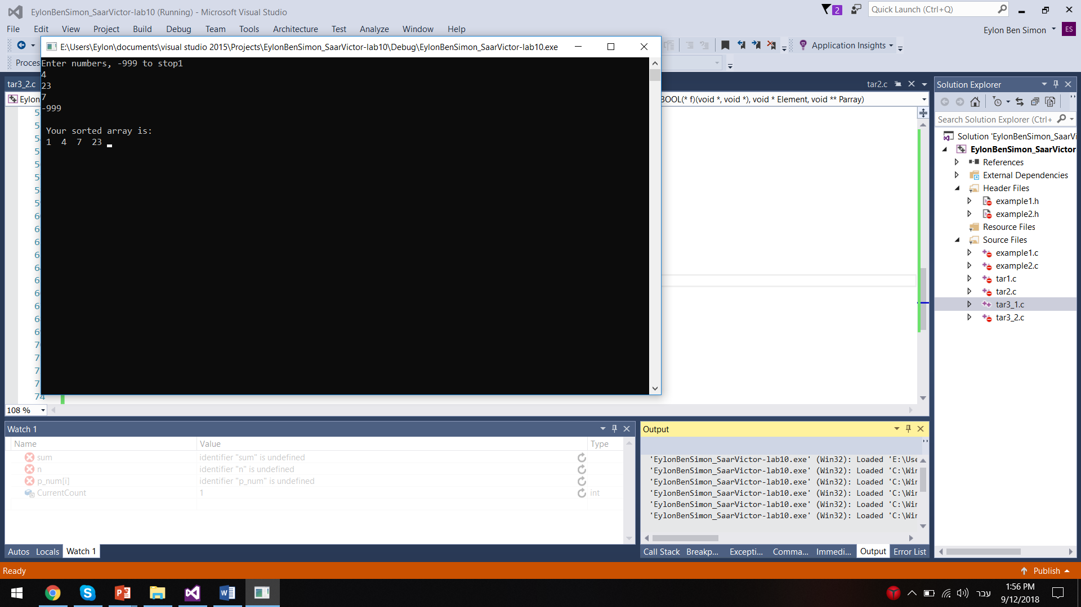

פלט 2:

